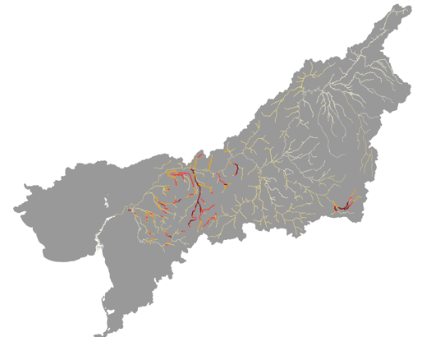

2019

2018

2017

Q4

Q3

Q2

Q1